|  |
| --- |
| EPAM Systems, RD Dep. |
| MTN.BI.07 Oracle Database Architecture |

|  |  |  |  |  |  |
| --- | --- | --- | --- | --- | --- |
| REVISION HISTORY | | | | | |
| Ver. | Description of Change | Author | Date | Approved | |
| Name | Effective Date |
| 1.0 | Initial status | [Kiryl Bucha](mailto:Kiryl_Bucha@epam.com) | 12-JAN-2012 |  |  |
| 2.0 | Updated in accordance with renewed content | [Elias Nema](mailto:Elias_Nema@epam.com) | 20-JAN-2014 |  |  |

Contents

1. Preparing to install Oracle 3

2. Installing Oracle Software Only 3

3. TNS Listener Status 13

4. Establish connection 13

5. Results 14

# Preparing to install Oracle

Add the information below to the bash_profile for **oracle** user:

# vi /home/oracle/.bash_profile

export ORACLE_HOSTNAME=ewbyminw0104t.localdomain

export ORACLE_UNQNAME=cdb1

export ORACLE_BASE=/u01/app/oracle

export ORACLE_HOME=$ORACLE_BASE/product/12.1.0.2/db_1

export ORACLE_SID=cdb1

export PATH=/usr/sbin:$PATH

export PATH=$ORACLE_HOME/bin:$PATH

export LD_LIBRARY_PATH=$ORACLE_HOME/lib:/lib:/usr/lib

export CLASSPATH=$ORACLE_HOME/jlib:$ORACLE_HOME/rdbms/jlib

Export DISPLAY variable:

**DISPLAY=192.168.1.1:0.0; export DISPLAY**

Login as **oracle** user. After that, extract achieved files using unzip command.

**unzip linux.x64_11gR2_database_1[2]of2.zip**

# Installing Oracle Software Only

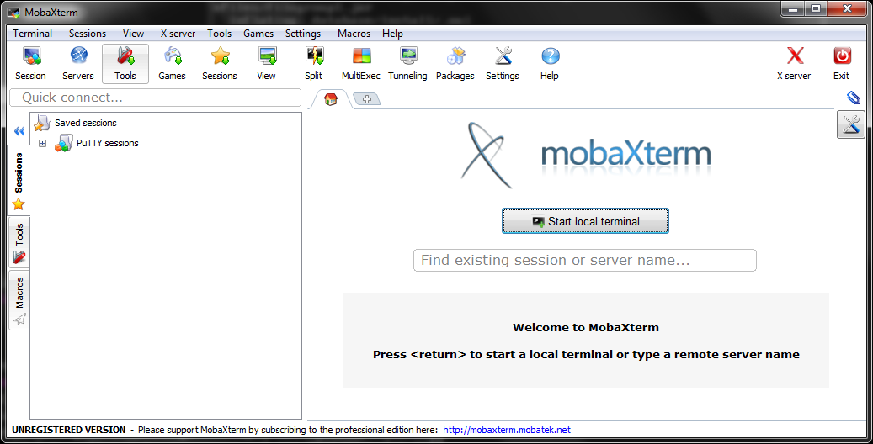

Get into the installation folder and run the next command:

**./runInstaller**

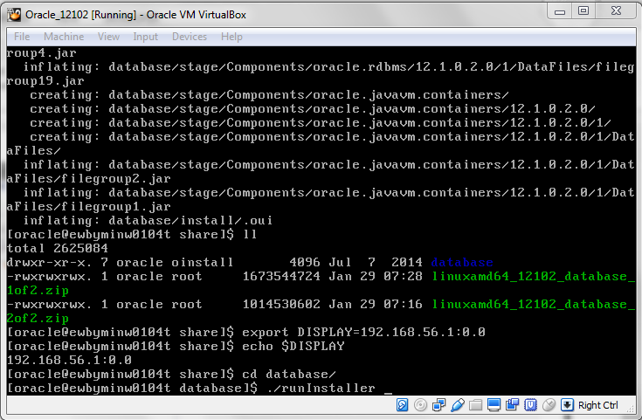

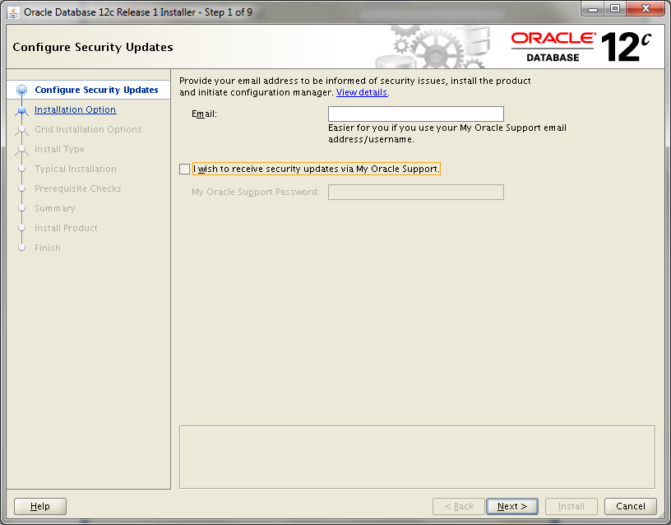

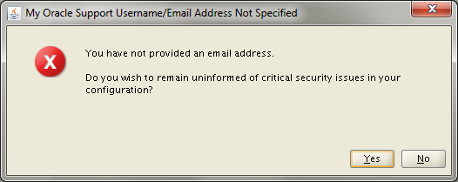

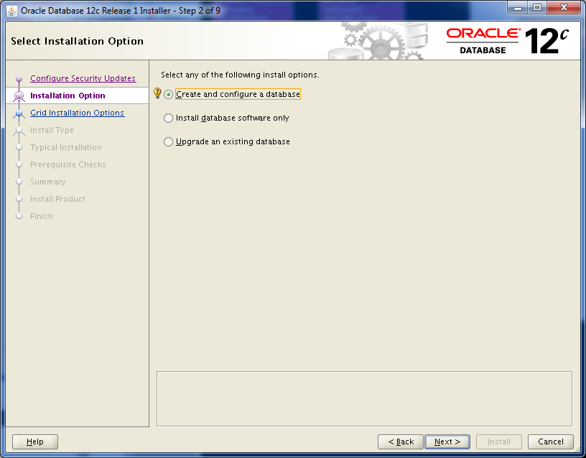

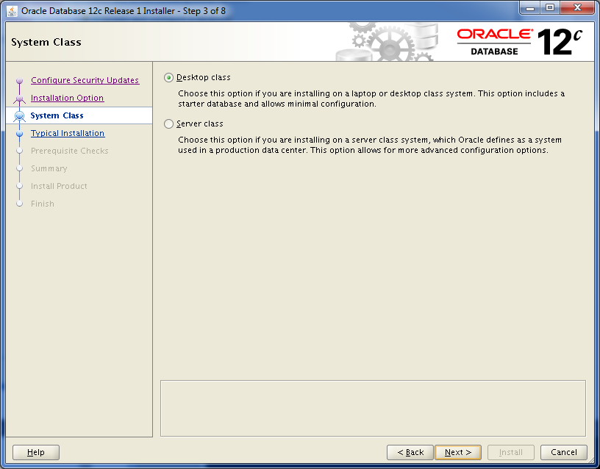

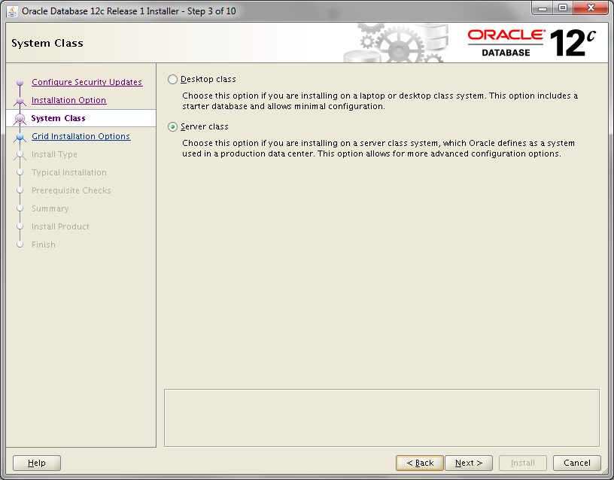

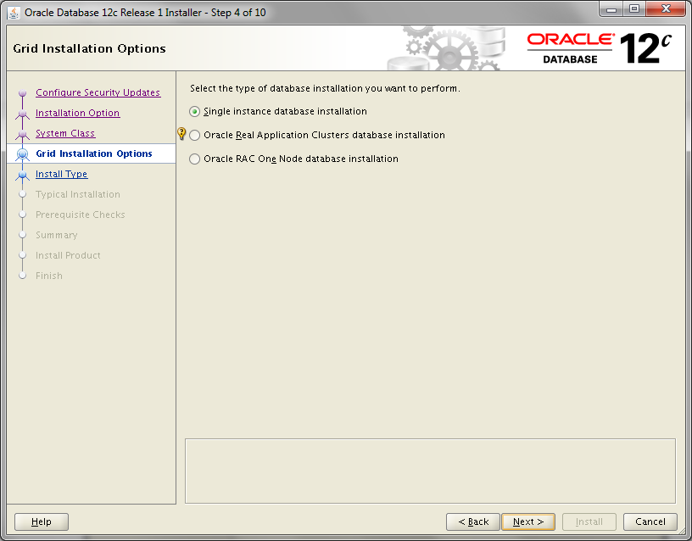

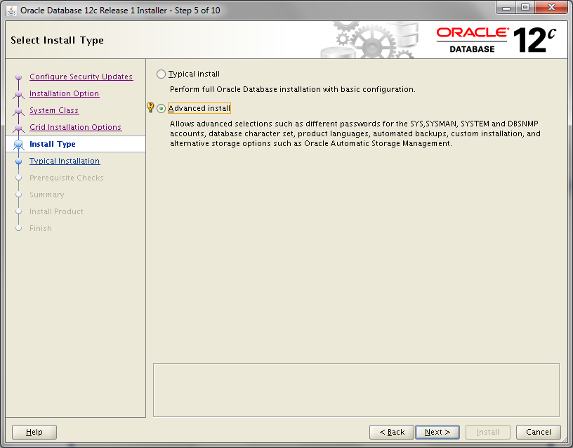

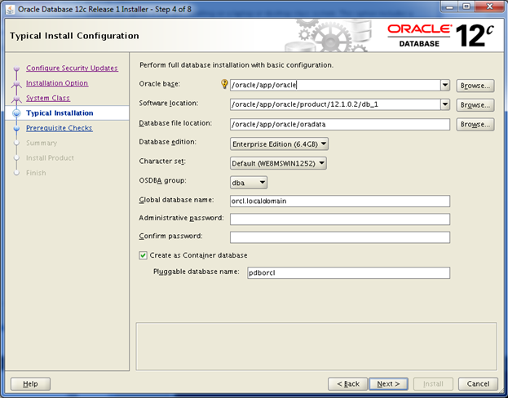

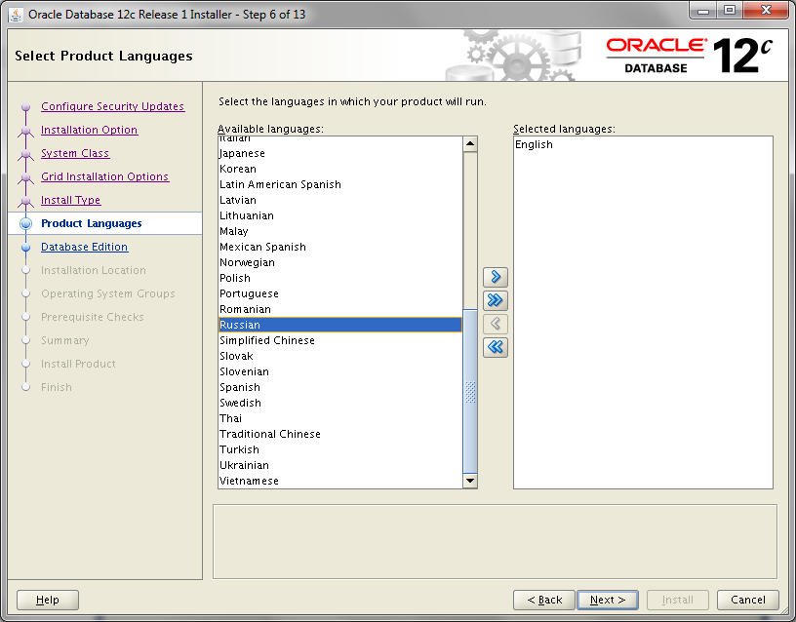

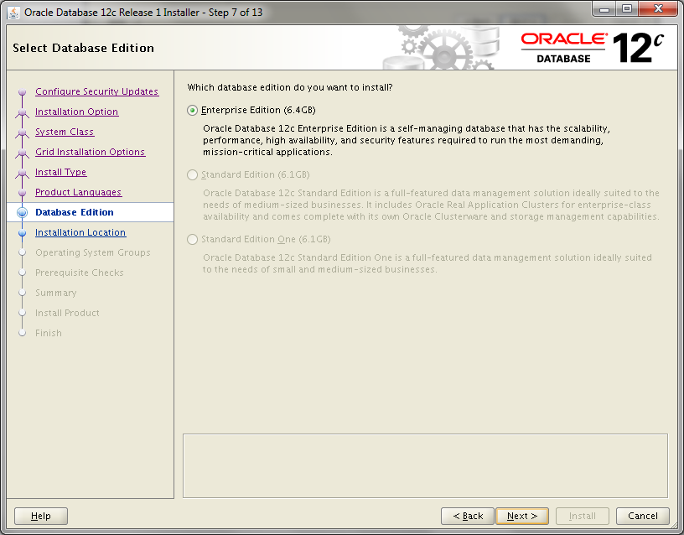

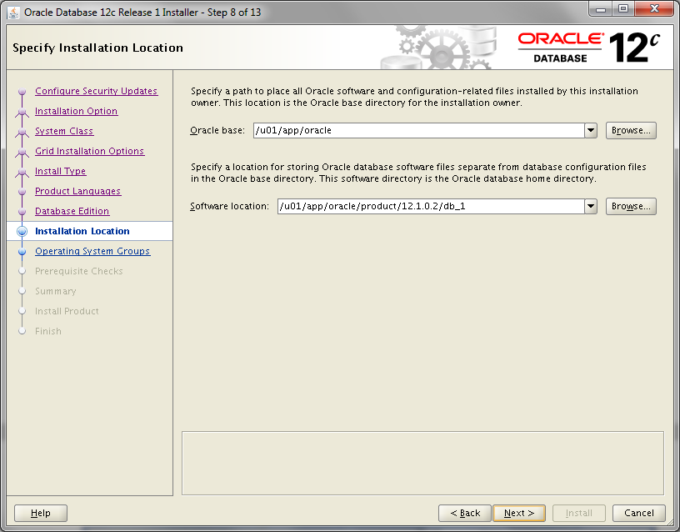

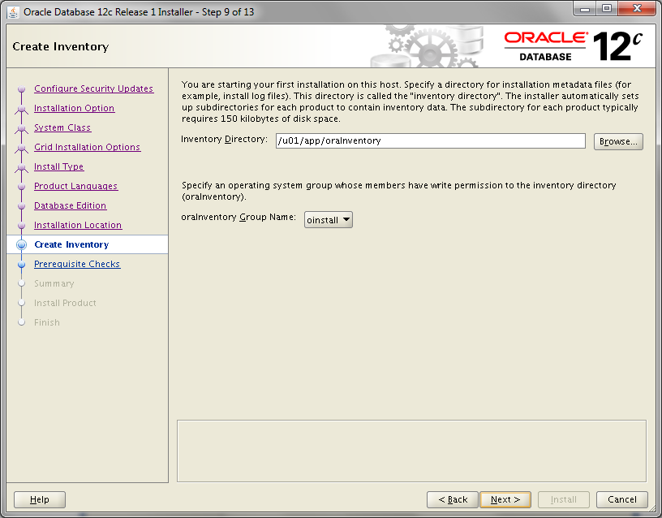

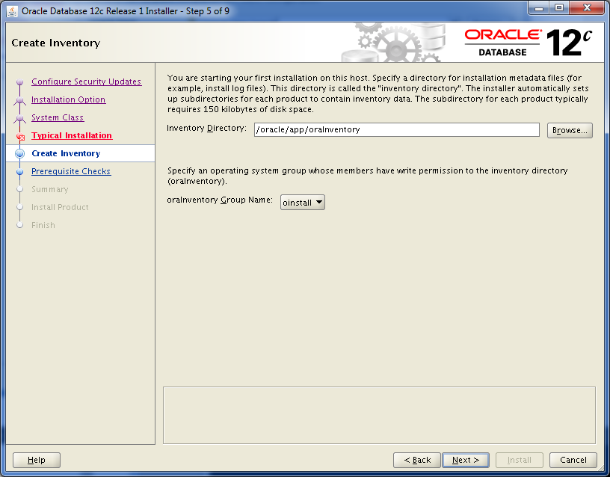

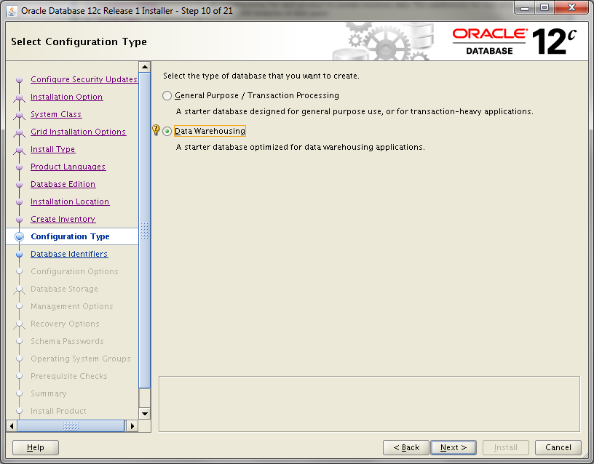

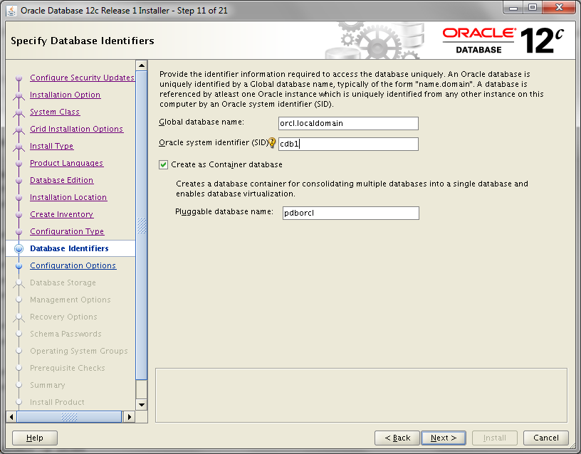

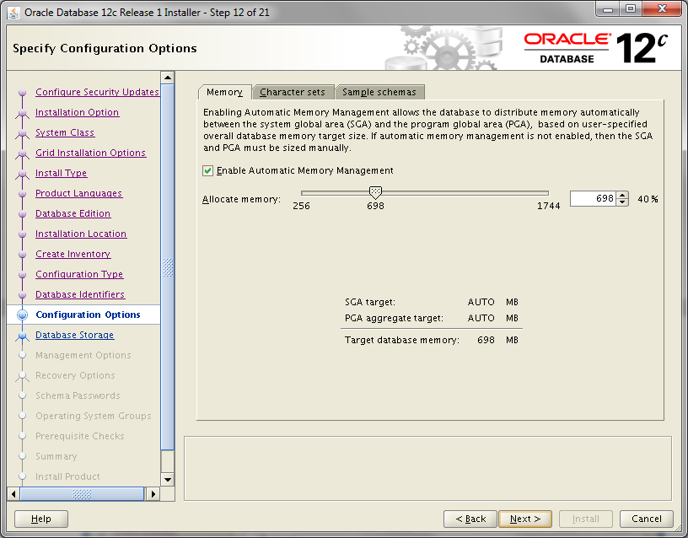

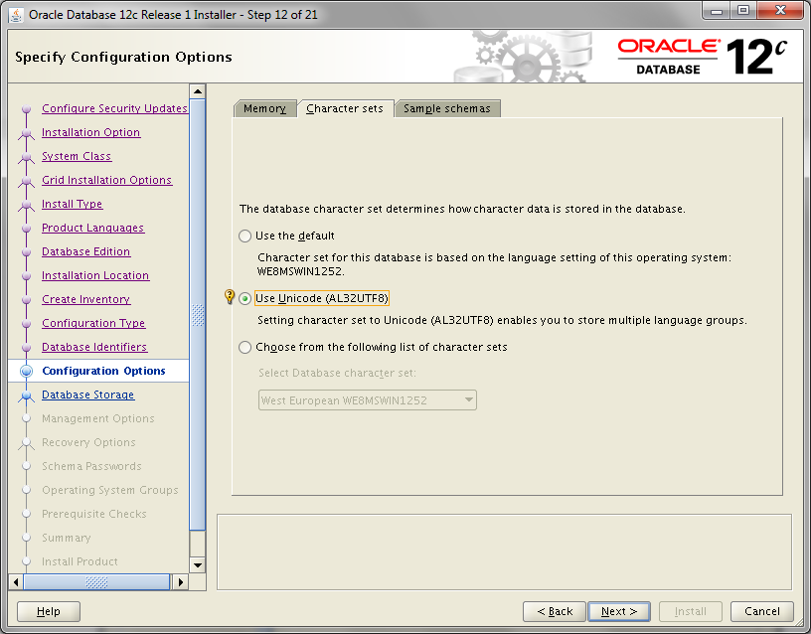

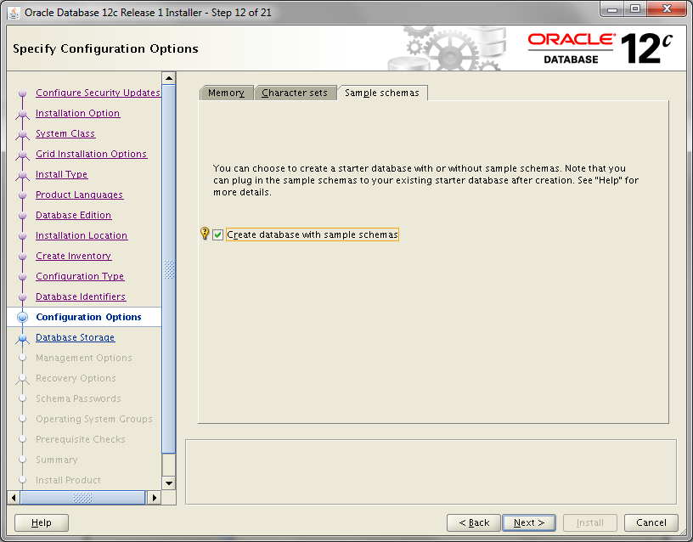

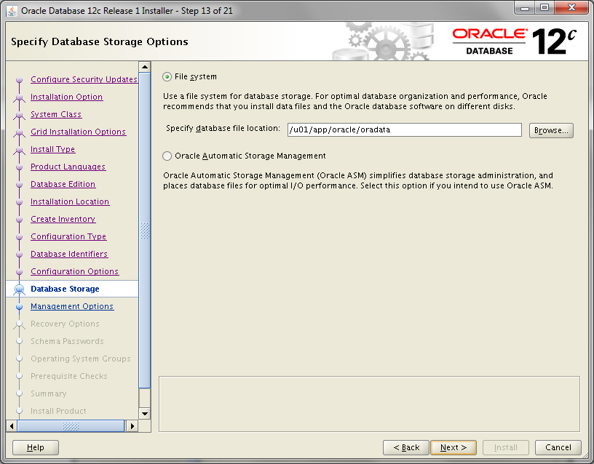

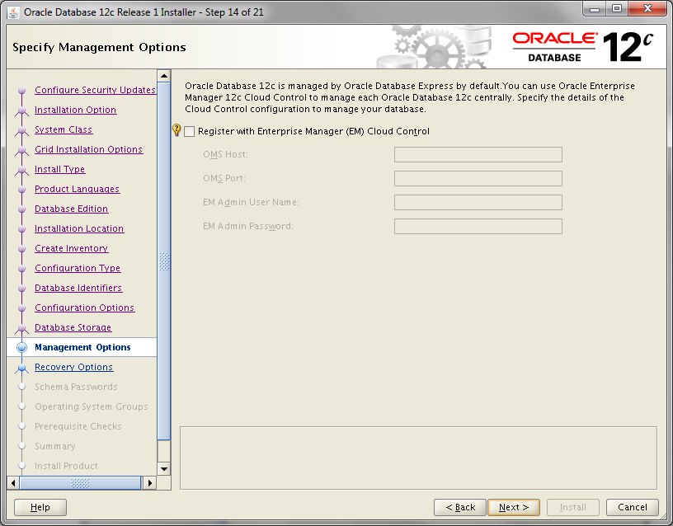

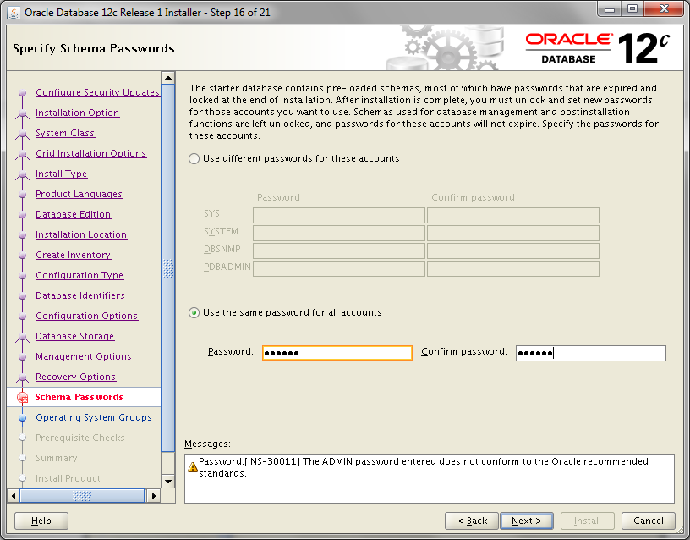

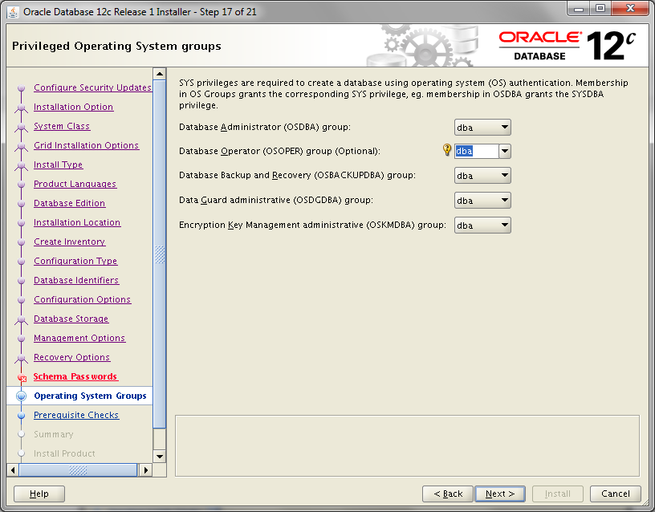

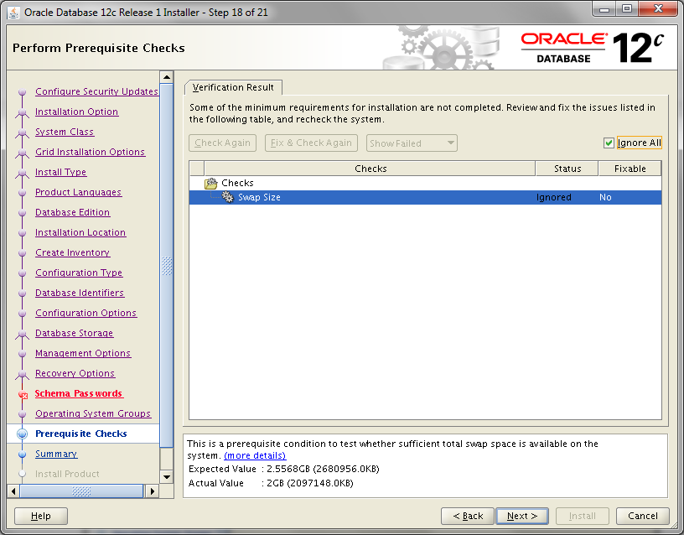

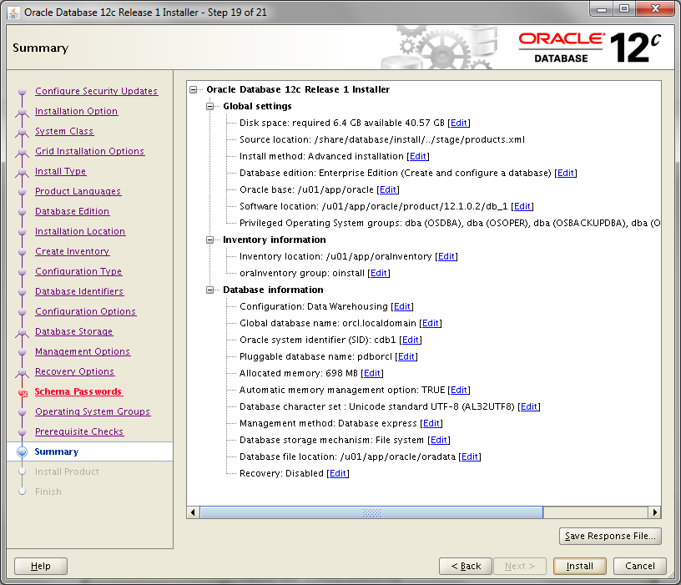

Use this file to attach to your report.

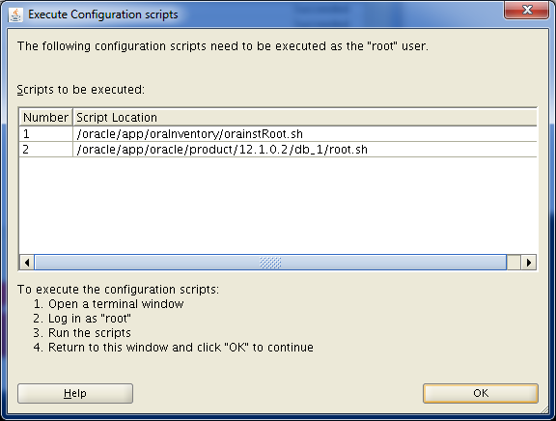

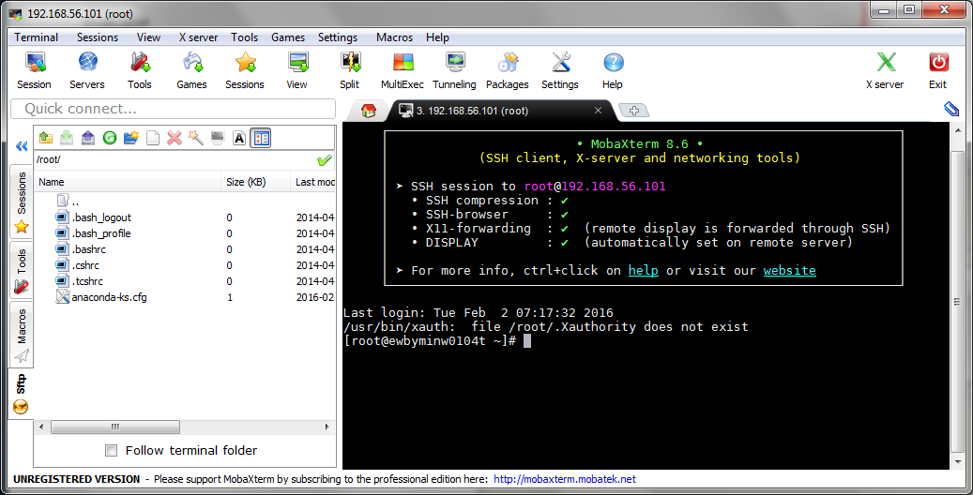

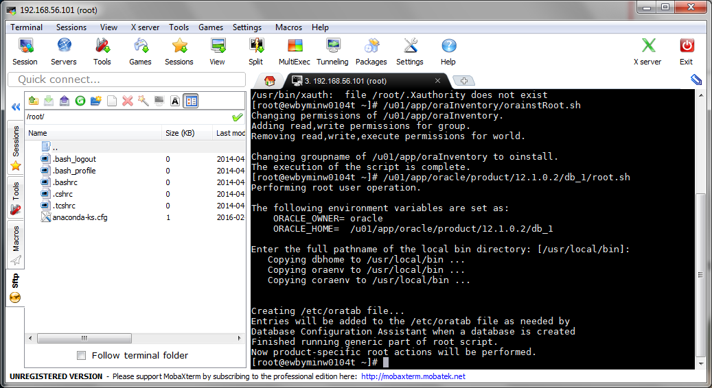

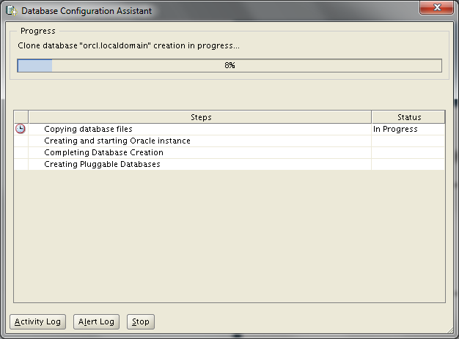

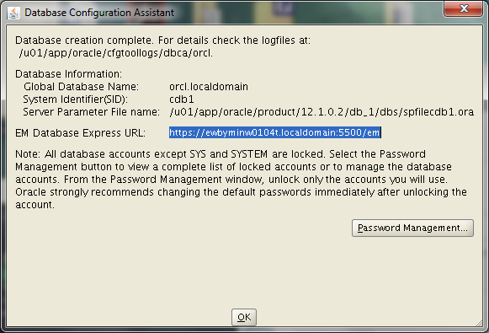

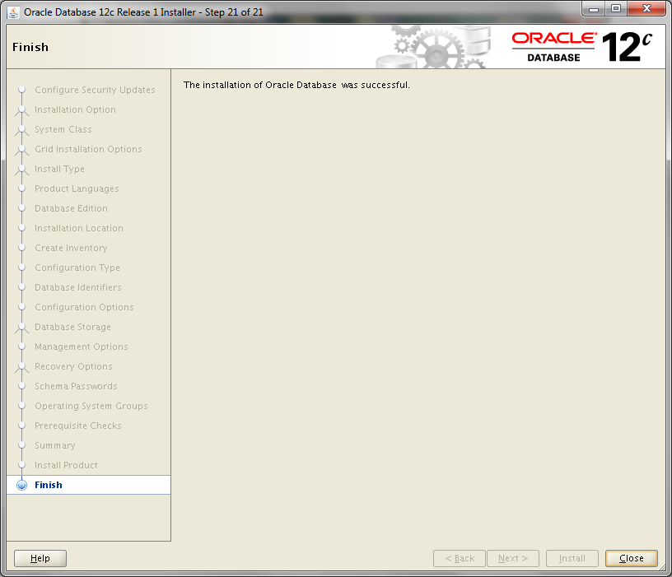

# TNS Listener Status

Check the status of the net listener:

**Lsnrctl status**

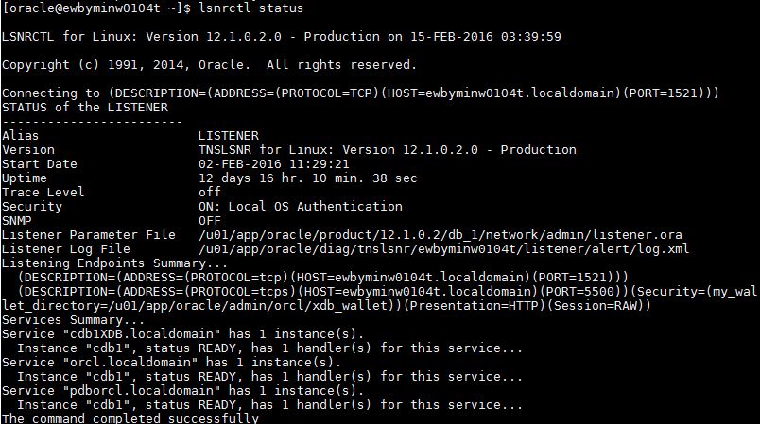

Description of configuration file:

**cat /u01/app/oracle/product/12.1.0.2/db_1/network/admin/listener.ora**

LISTENER =

(DESCRIPTION_LIST =

(DESCRIPTION =

(ADDRESS = (PROTOCOL = TCP)(HOST = ewbyminw0104t.localdomain)(PORT = 1521))

(ADDRESS = (PROTOCOL = IPC)(KEY = EXTPROC1521))

)

)

NOTE: To Start, Stop or get Status of Listeners use lsnrctl (help, start, stop, status …)

# Establish connection

Connect to the Oracle Db via SQL Developer. Start with sys user for the pdb container (see below):

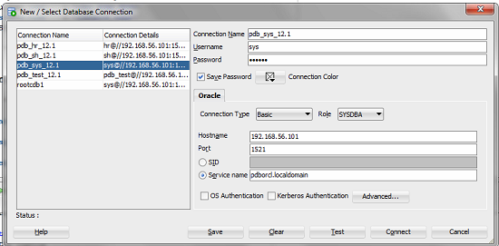

# Results

* Reboot Virtual Machine
* Restart Listener:
* Start Oracle Database Instance:
* Attach response file (see one the slides above) to the report.
* Connect to the Oracle DB via SQL Deveoper.